38.To design TM for wcw in automata.

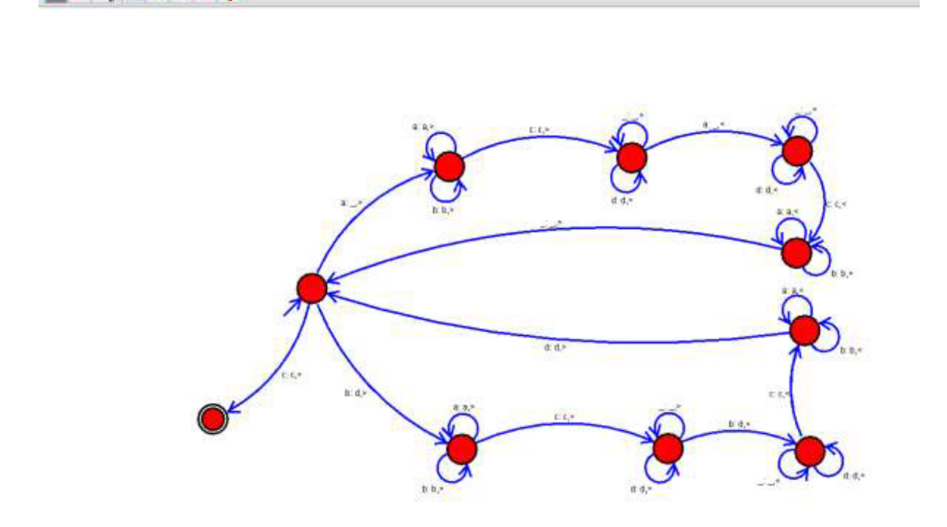

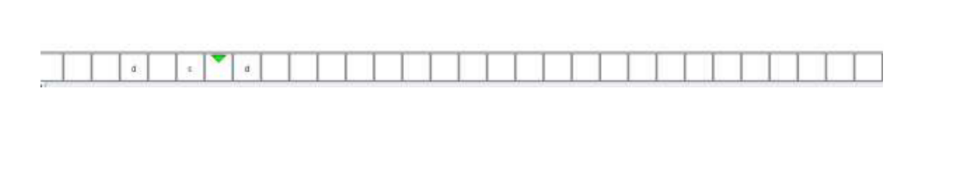

**Result:** Thus designing TM of WCW is done and verified by giving sample inputs.